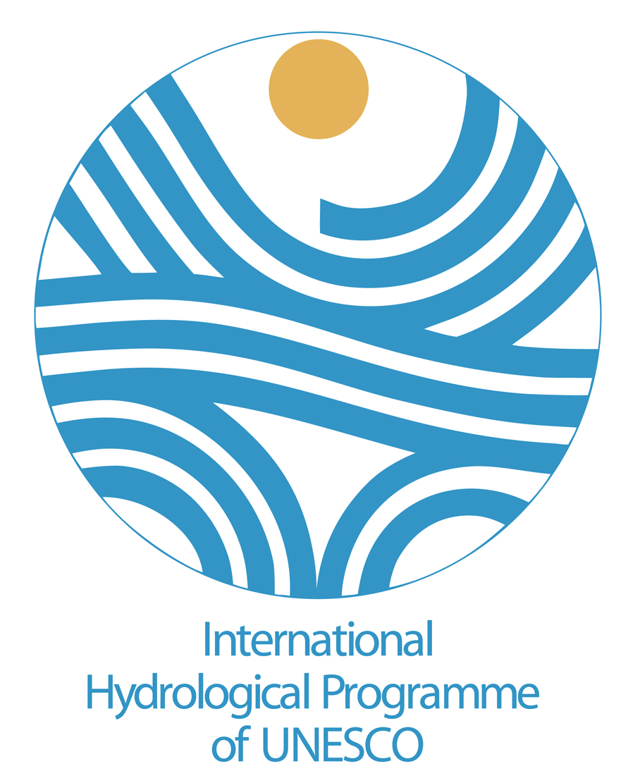
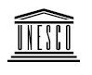
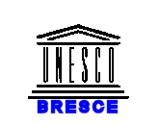

UNECE

UNESCO-UNECE-INWEB JOINT MEETING

Transboundary Groundwaters in South-Eastern Europe:
Assessment and future perspectives

23rd-24th April, 2007
Thessaloniki, Greece

FINAL REPORT

May 2007

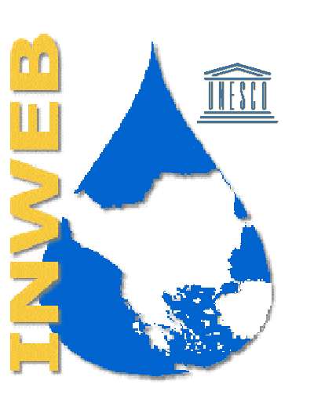

Prepared by
UNESCO Chair and Network “INWEB” at the Aristotle University of Thessaloniki
“The International Chair and Network of Water-Environment Centres for the Balkans”

CONTENTS

1. Introduction
2. Workshop Findings and Conclusions
3. Recommendations for Phase II of the ISARM of the Balkans

Annex 1 Data Collection Questionnaire
Annex 2 List of Participants
Annex 3 Meeting Agenda
Annex 4* Presentations
Annex 5* UNECE Preliminary Assessment of Transboundary Groundwaters in SEE
Annex 6* Phase I of ISARM/Balkans Internationally Shared Aquifers in the Balkan Region: Preliminary Assessment

*sent as separate file

1. INTRODUCTION

1.1 Background

UNESCO Chair INWEB, in cooperation with UNESCO (Paris and Venice Office)and UNECE (Geneva) organized in Thessaloniki from 23rd-24th April 2007 a workshop entitled:

Transboundary Groundwaters in SEE: Assessment and Future Perspectives

The workshop had two main objectives. Firstly to review and finalise the assessment of transboundary groundwaters in SEE, and secondly to identify possible follow-up activities concerned with transboundary groundwater resources management in the region. The first objective comprises the main part of the UNECE mandate to its members, which is to analyse the current status, regional issues and problems concerning shared groundwaters, to set out the scale and scope of transboundary groundwaters in the region and their importance in supporting human uses, to examine the pressure factors on these groundwater bodies and to provide information on status, trends and impacts in relation to both quantity and quality as well as on the management measures being taken, planned or needed to prevent, control or reduce transboundary impacts in groundwaters in the region. The second objective is part of the common missions of both UNESCO and UNECE regarding the development of pilot projects and strengthening cooperation between riparian countries.

The UNESCO approach in particular is much broader than that defined in this workshop, since UNESCO deals with scientific methodologies, capacity building, tools and supporting activities in order to suggest ways for achieving sustainable management of internationally shared water resources. With this aim in mind, UNESCO has developed the UNESCO ISARM programme which aims at improving understanding of scientific, socio-economic, legal, institutional and environmental issues related to the management of transboundary aquifers. The programme operates through a joint coordination committee of experts from UNESCO-IHP, the International Association of Hydrogeologists (IAH), the Food and Agriculture Organisation of the United Nations (FAO) and the United Nations Economic Commission for Europe (UNECE). As a first step the programme has initiated the inventory of Transboundary Aquifers of the World.
The UNESCO ISARM programme has initiated regional initiatives, starting in Africa in 2002, and followed by the Americas in 2003 and SEE in 2004, when a workshop organised in cooperation with the UNECE, IAH/ Transboundary Aquifer Resource Management (TARM) Commission, The Economic and Social Commission for West Asia (ESCWA) and the Observatoire du Sahara et du Sahel (OSS)was held in Thessaloniki on «Key Issues for Sustainable Management of Transboundary Aquifers in the Mediterranean and in South Eastern Europe.» The workshop resulted in a first draft inventory identifying 45 transboundary aquifers and provided recommendations for developing a regional project for sustainable management of internationally shared groundwater resources. Individual projects and priorities were also identified.
This report is the result of the UNESCO-ISARM initiative on transboundary aquifers in SEE coordinated by Alice Aureli (Paris) in collaboration with UNESCO-BRESCE (Ph. Pypaert, Venice Office) and the United Nations Economic Commission for Europe (UNECE). It summarises the main results and recommendations of the current workshop and is accompanied by the UNECE draft assessment (Annex 5), which was coordinated and managed for UNECE by the British Geological Survey, and undertaken in collaboration with the UNESCO Chair INWEB. Further support was provided by the UNESCO-Venice Office (UNESCO-BRESCE) and the International Groundwater Assessment Centre (IGRAC).

The revised inventory is based largely on responses to a specifically designed data collection questionnaire (Annex 1) prepared by the UNECE Groundwater Core Group and distributed in July 2006 to national focal points. The information thus obtained served to supplement and update existing information from the previous UNECE inventory of transboundary groundwaters, from the SEE regional inventory undertaken by the UNESCO Chair INWEB, from the UNESCO Chair INWEB transboundary groundwaters workshop held in Thessaloniki in 2004, and from other sources such as the EEA and the UNEP Global International Waters Assessment (UNEP/GIWA).

The UNECE assessment covers transboundary groundwaters shared by two or more of the following countries: Hungary, Slovenia, Croatia, Romania, Serbia, Bosnia and Herzegovina, Montenegro, the Former Yugoslav Republic of Macedonia, Albania, Bulgaria, Greece and Turkey. Some transboundary groundwaters in the region have been identified and known for a considerable time and were noted by earlier UNECE and UNESCO Chair INWEB inventories. However, SEE has seen major conflict and political change in the last fifteen years; aquifers and groundwaters that for many years were located within a single country are now shared between new countries. Thus while the previous UNECE inventory recorded 23 transboundary aquifers in the region and the UNESCO Chair INWEB inventory reported 47, the present assessment has identified 65. In some cases, these are not yet formally recognised as such, and it has been difficult to obtain information for them.

This report is also accompanied by Phase I of UNESCO-ISARM/Balkans Preliminary Assessment of Internationally Shared Aquifers in the Region (Annex 6 – sent as a separate file).

In fact, although the assessment of the current situation in both documents (Annexes 5 and 6) is the same, the UNESCO draft inventory contains much more information about the hydrogeological condtions, the institutions involved, the legal status and uses of groundwater in individual transboundary aquifers. This information could be useful at a later stage in order to analyse in depth alternative measures for sustainable transboundary groundwater management in specific cases.

1.2. Basic information on the region

The Balkan Peninsula in SEE extends from the Bay of Trieste west to the Danube River Delta in the eastern Black Sea. The northern geographical boundary of the Balkan region is traditionally considered to be the Danube River, although Romania also belongs to the Balkans. The 10 Balkan countries (*) are shown in Figure 1.

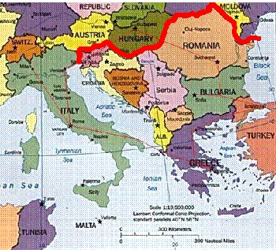

Figure 1: Countries in the Balkan region.

The Balkan Peninsula covers an area of around 520,000 km² and has about 45 million inhabitants. Almost all the main rivers in the Balkans, except those of Central and South Greece, are internationally shared. This means that the majority (about 90%) of the land belongs to transboundary river catchments (Figure 2).

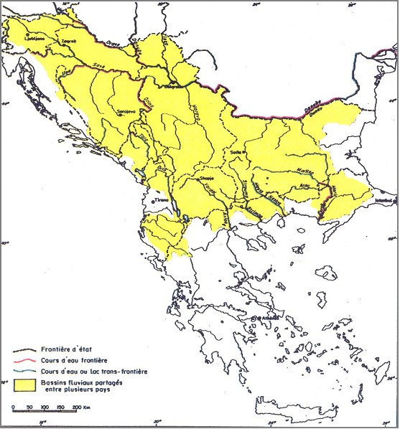

Figure 2: Area covered by internationally shared rivers in the Balkan region.

1.3 Workshop Preparation and Activities

1.3.1 Data collection

The assessment methodology broadly followed the guidance provided by UNECEin using the DPSIR framework to describe:
- the pressures acting on the groundwaters resulting from human activities
- the status in terms of both quantity and quality of the groundwaters and the impacts resulting from any deterioration in status
- the responses in terms of management measures that have already been introduced and applied, need to be applied or are currently planned.

A specifically designed data collection questionnaire (Annex 1) prepared by the UNECE Groundwater Core Group was distributed in July 2006 to national focal points, and on the basis of the information provided a draft assessment was prepared.

1.3.2 Selection of participants

UNESCO IHP, UNESCO Chair INWEB, UNECE and the British Geological Survey consulted together to ensure that the most suitable participants from each of the Balkan countries was nominated to attend the workshop, and nominees were asked to submit their CVs. The nominations were then carefully examined for suitability, and care was taken to ensure that as far as possible the final group selected consisted of an even distribution of nationality and gender. Certain difficulties presented themselves with regard to prior commitments of nominees (Montenegro), obtaining visas for travel to Greece (Albania), receiving permission from the Ministry to attend (FYR of Macedonia) and finding a suitable participant (Turkey) and the final group did not completely represent the whole region. The final group consisted of 17 experts from 12 different countries, plus 2 locals from the Aristotle University of Thessaloniki providing technical assistance and one local from the UNESCO Chair INWEB providing secretarial assistance (see Annex 2).

1.3.3 Budget

A budget was agreed with UNESCO/IHP and UNECE. In general, UNECE covered participants’ travelling and UNESCO/IHP their accommodation and subsistence. Travel arrangements were agreed with participants, support for participants requiring visas for travel to Greece provided, and tickets sent either electronically or by pre-paid ticket advice.

1.3.4 Venue

It was important that the selected venue adequately reflected the level of professionalism of the group and UNESCO’s and UNECE’s own profile. Since a long day was to be spent in the meeting room it was crucial that the meeting room offered a good level of comfort, and that the adjacent public rooms were conducive to small, informal group discussions taking place. It had been decided to keep coffee and lunch breaks to a minimum length of time, and it was therefore also necessary to find a hotel that could provide catering very close to the meeting room, preferably in an adjacent room, to avoid participants disappearing within the building during breaks. Having considered the facilities and rates offered by several hotels in Thessaloniki, the Park Hotel was finally selected as being the most suitable.

All participants were provided with detailed information on the venue and the individual arrangements made for them.

1.3.5 Activities

On the basis of the information provided, national experts, as well as experts from UNESCO, UNECE and IGRAC, were invited to Thessaloniki to attend the two-day workshop (see agenda in Annex 3). The draft assessment was sent to workshop participants prior to the meeting, and gaps in information were highlighted. Participants were requested to provide additional information for the assessment of aquifers shared by their countries and to confirm information on general aquifer characteristics, use and functions, management problems and responses described in the draft assessment.

In the morning of the first day of the workshop country experts made presentations of national reports (see Annex 4), and there was some general discussion on the aims and output to be produced by the workshop. In the afternoon participants were divided into groups consisting of representatives from neighbouring countries, and they discussed and debated common characteristics of shared aquifers. Group discussion continued in the morning of the second day, and conclusions were drawn and recommendations for follow-up activities were summarised.

- WORKSHOP FINDINGS AND CONCLUSIONS

- Transboundary groundwater resources play a significant role in the SEE region. The physical environment of the region – the geology, topography and major catchments – is such as to promote the occurrence of productive aquifers. These aquifers are of two distinctive main types – the limestones of the karstic type area of the Dinaric coast and its mountainous hinterland, and the thick alluvial sedimentary sequences of the Danube basin, mainly those associated with the Danube River itself and its tributaries. In some locations the alluvial sediments overlie and are in hydraulic contact with the limestones or comprise relatively thin aquifers in river or lake sediments overlying ancient metamorphic rocks.

- The location of groundwater aquifers covered by this assessment are shown in Figure 3 below. From this map, the geographical distinction between the two main aquifer types is clear, and it can be seen that several of the countries of the region have much of their national borders traversed by transboundary groundwaters.

Figure 3. Distribution of transboundary groundwater aquifers in the SEE region.

- Transboundary karstic groundwater aquifers were reported to provide 60 to 80 per cent of total water usage in their respective areas, and some of the Dinaric karstic aquifers of Bosnia, Serbia, Croatia, Montenegro and Albania as much as 90 or even 100 per cent. In terms of numbers, the importance of transboundary karstic aquifers is shown in Figures 4 and 5.

Figure 4. Distribution by country of the total number of transboundary and karst transboundary aquifers in SEE.

Figure 5. Distribution by country of karst transboundary aquifers (as % of the total) in SEE.

- The alluvial aquifers exhibit a greater range of use relative to surface water, with the proportion of groundwater varying from only 15 per cent for some, up to 70 per cent for the important Banat, Backa and Srem alluvial aquifers along the River Danube in Serbia, Croatia and Hungary.

- The majority of transboundary aquifers, except those who are located in remote loosely populated areas, are very vulnerable to anthropogenic pollutants emitted from both point and non-point sources. Karstic aquifers, with their lack of soil cover and rapid flow paths leaving little time for attenuation, are almost invariably classified as highly vulnerable. Alluvial aquifers are also likely to be considered as vulnerable, unless they contain a high proportion of clay-rich material to reduce their permeability, are overlain by a protective confining layer of clays and/or the water table is relatively deep. The transboundary groundwaters of the SEE region are likely, therefore, to be highly vulnerable to pollution if the pressure factors outlined below produce significant loadings of mobile and persistent pollutants.

- In general, both alluvial and karstic aquifers have reported groundwater quality problems. Of the questionnaires received, only two specifically reported that there were no groundwater quality issues at all, and several more were incomplete.

- It could be generally concluded that although transboundary aquifer resources in the region are very important sources of water for different uses (drinking, irrigation and for industries) there is lack of reliable data on groundwater quantity and quality. Examples of good management practices for sustainable use of transboundary water resources are missing. Except of some few cases, management of transboundary aquifers is far for being satisfactory. Lack of systematic monitoring, absence of local and regional cooperation agreements and weak capacity of national institutions involved are the main causes for this situation.

3. RECOMMENDATIONS FOR PHASE II OF THE ISARM OF THE BALKANS

Transboundary groundwater protection plans and sustainable management of shared groundwater resources in the Balkan region should be based on strong cooperation between countries involved, and joint projects should be developed. Of primary importance are:

- development of common monitoring systems
- sharing of data
- establishment of multi-lateral and multi-disciplinary aquifer commissions
- development of common research projects with harmonised methodology

For karst transboundary aquifers, which are very important in the region, the main difficulties are related to the following:
- karst aquifers are heterogeneous with anisotropic surface and underground formations; and have well developed, complex, deep and unknown underground karst conduits, fissures, joints and cracks
- a strong interaction exists between the circulation of surface water and groundwater; and between inflow (ponors) and outflow (karst springs)
- there are significant and rapid variations in groundwater level
- the influence of man's induced structures and activities is important (dams, reservoirs, etc.).

The main long-term goal of ISARM-Balkans project is to:

• Develop regional groundwater governance in order to ensure effective management of transboundary groundwater resources, taking into account environmental risks associated with various water pollutants and risks from potential conflicts over sharing transboundary aquifer resources.

In order to achieve this goal, and taking into account the results of the workshop, the following recommendations could be made for Phase II of ISARM-Balkans:

- Complete the actual inventory by including hydrogeological maps of transboundary aquifers
- Develop an Internet GIS-based database of transboundary aquifer resources in SEE
- Identify gaps and potential conflicts in groundwater national governance and also in bilateral and regional cooperation and coordination
- Establish a common knowledge base, a cooperative framework and coordination mechanism for managing transboundary aquifers, according to the EU Water Framework Directive 2000/60
- Develop a common action plan and a regional research agenda for capacity building and key challenges in managing transboundary groundwater resources.

INWEB in cooperation with UNESCO-ISARM, UNESCO-BRESCE and UNECE is developing more detailed proposals and actions in order to achieve the above.

Annex 1 Data Collection Questionnaire

QUESTIONNAIRE FOR THE ASSESSMENT OF GROUNDWATER IN TRANSBOUNDARY AQUIFERS

Country....................................... Aquifer........................................... Shared with .............................

A. Brief description of the transboundary aquifer

1. Please look at the four simplified pictures of groundwater systems below and indicate in the boxes which of them most closely characterizes your transboundary aquifer. If none of the four, then please provide a conceptual sketch of your transboundary aquifer in the blank box below.

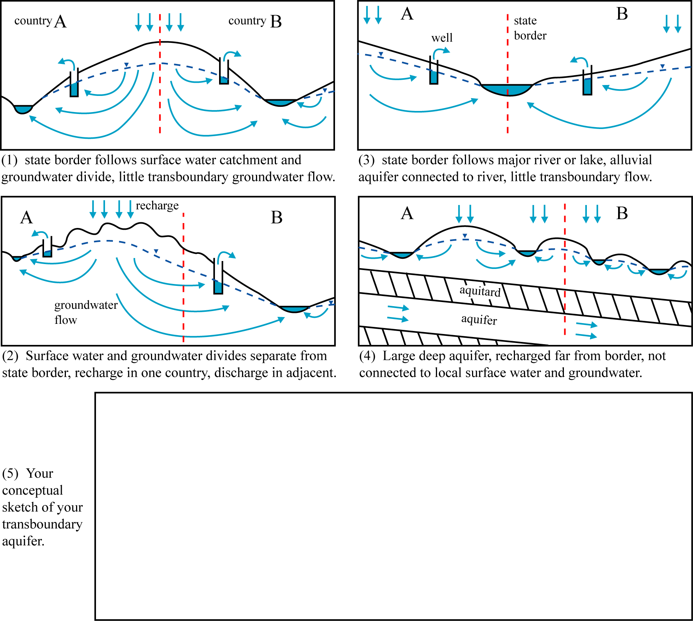
Please tick: Example 1 □ 2 □ 3 □ 4 □ 5 □
2. Indicate the general characteristics of the aquifer in your country
a) Predominant lithology or lithologies..................................................................................................
b) Stratigraphy and age ..........................................................................................................................
c) Thickness: mean (m)............. maximum (m)............... d) Areal extent (km²)..........................….
e) Dominant groundwater flow direction: from.. ........................... to ............................... (countries)
f) Link with surface water systems: strong □ medium □ weak □

3. Please provide a clear map of the transboundary aquifer, including its boundaries and adequate geographical reference (coordinates, projection type and projection parameters), preferably as a GIS-file.

B. Importance of groundwater in the transboundary aquifer

Please provide information for the part of the aquifer in your country

- Uses and functions

Does the groundwater in this transboundary aquifer have direct uses and/or other functions?
No □ Why not? Irrelevant groundwater resource □
(no demand for groundwater)
Problems with groundwater □
(if so, indicate these in section C)
or:
Yes □ Uses □ Groundwater as % of total water use ...........
Other functions: Support of ecosystems □
Support of agriculture □
(directly from shallow water table)
Preventing land subsidence □
Maintaining baseflow and springs □
Seasonal heat storage □
Any other function □
(please specify).....................................

2. Groundwater abstraction and use in the transboundary aquifer

Indicate in the table the percentage of total groundwater abstraction accounted for by each use
Type of use | Percentage | If you do not know the exact percentage, then mark one of the following options
Type of use | Percentage | < 25 % | 25 – 50 % | 50 – 75 % | > 75 %
Drinking water
Irrigation
Industry
Mining
Thermal spa
Livestock
Other (please specify)
Please indicate the year to which these figures apply................

C. Which problems are observed in groundwater in the transboundary aquifer?

1. Problems related to groundwater quantity

a) Specify if possible the average trend of groundwater level decline (m/year) ..................

b) Indicate in the table the type and scale of problem associated with groundwater abstraction from the aquifer

Problem | Increasing scale of problem
Problem | 1. Local and moderate | 2. Local but severe | 3. Widespread but moderate | 4. Widespread and severe
Increased pumping lifts or costs
Reduction of borehole yields
Reduced baseflow and springflow
Degradation of ecosystems
Sea water intrusion
Salt water upconing
Polluted water drawn into aquifer
Land subsidence
Other (please specify)

2. Problems related to groundwater quality

Indicate in the table the type, nature and scale of groundwater quality problems in the aquifer

Problem | Nature of problem |  | Typical range of concentrations | Scale, using classes 1–4 from table above
Problem | Natural origins | From which human activities¹ | Typical range of concentrations | Scale, using classes 1–4 from table above
Salinization
Nitrogen species
Pesticides
Heavy metals
Pathogens
Industrial organic compounds
Hydrocarbons
Other (please specify)
¹insert: irrigation, mining, agriculture, industry, waste disposal, sanitation, sewer leakage or others as required
3. Evidence for transboundary effects

- Do you observe any decline of groundwater levels (or piezometric levels) caused or probably caused by activities in neighbouring countries?
Yes □ No □

- Do you observe any groundwater pollution caused or probably caused by activities in neighbouring countries?
Yes □ No □

D. Groundwater management measures for the transboundary aquifer

Indicate in the table which measures are presently being implemented or need to be applied in your part of the aquifer

Management Measures | Already used and effective | Used, but need to be improved | Need to be applied | Currently planned
Transboundary institutions (commissions, agreements, treaties, etc.)
Groundwater abstraction management by regulation (licensing, taxation)
Groundwater abstraction management by incentives or disincentives (subsidies, credits, energy prices, energy supply, etc.)
Increasing efficiency of groundwater use
Monitoring of groundwater quantity
Monitoring of groundwater quality
Public awareness campaigns
Protection zones for public supplies
Vulnerability mapping for land use planning
Good agricultural practices
Groundwater integrated into river basin management
Wastewater reuse or artificial recharge
Treatment of urban wastewater
Exchange of data between countries
Treatment of industrial effluents
Other (please specify)

Please provide name, institution, address details and e-mail address of the person who filled in this questionnaire
..................................................................................................................................................................................................................................................................................................................................…..………….....................................................………………………………………………………………………….

Annex 2 List of Participants

Transboundary Groundwaters in South-Eastern Europe:
Assessment and future perspectives

23rd-24th April, 2007
Thessaloniki, Greece

LIST OF PARTICIPANTS

Bernadini, Francesca | United Nations Economic Commission for Europe (UNECE)  Switzerland  Tel: +41 22 917 24 63 / 14 99  Fax: +41 22 917 01 07  Francesca.Bernardini@unece.org
Bretotean, Mihai Viorel | National Institute of Hydrology and Water Management  Romania  Tel: +40 2 131 81111  Fax: +40 2 131 81116  mihai.bretotean@hidro.ro
Chilton, John | British Geological Survey  U.K.  Tel: + 44 1491 69 22 84  Fax: 44 1491 69 23 45  pjch@bgs.ac.uk
Cupic, Daria | Croatian Waters  Croatia  Tel: +38516307380  Fax: +38516307686  Daria.Cupic@voda.hr
Djuric, Dusan | Jaroslav Cerni Institute for Water Management  Serbia & Montenegro  Tel: +381 113906478  Fax: +381 113906478  dusan.djuric@jcerni.co.yu
Faloutsos, Dimitris | Global Water Partnership-Mediterranean (GWP-Med)  Greece  Tel: +30 210 32 47 490, +30 210 32 47 267  Fax: +30210-3317127  secretariat@gwpmed.org, dimitris@gwpmed.org
Gancheva-Vaseva, Nevyana | Black Sea Basin Directorate  Bulgaria  Tel: +359 52 631 447  Fax: +359 52 631 448  bdvarna@bsbd.org
Ganoulis, Jacques | UNESCO Chair INWEB  Greece  Tel: +30 2310 99 56 82  Fax: +30 2310 99 56 81  iganouli@civil.auth.gr
Georgievski, Saso | GEING Krebs und Kifer  FYR of Macedonia  Tel:+ 38923109795  Fax: + 38923109795  sasozingo@yahoo.co.uk, geing@geing.com.mk
Kukuric, Nebojsa | IGRAC (International Groundwater Resources Assessment Centre)  The Netherlands  Tel: +31 30 256 4935  Fax: +31 30 256 4855  Neno.kukuric@tno.nl
Lipiridis, Charis | Aristotle University of Thessaloniki  Greece  Tel: +30 6944 365 370  Fax: none  charislipiridis@yahoo.gr
Mijatovic, Borivoje | Serbia & Montenegro National Committee of IAH  Serbia & Montenegro  Tel: +381 63 306 335  borismij@EUnet.yu
Mikulic, Zlatko | Environmental Agency of the Republic of Slovenia  Slovenia  Tel: + 386 1 478 41 53  Fax: + 386 1 478 40 50  zlatko.mikulic@rzs-hm.si
Pantelopoulos, Pantelis | Hellenic Ministry for the Environment, Physical Planning and Public Works  Greece  Tel.: +30 210 8645762  Fax: +30 210 8653150  abassiak@math.uoa.gr
Pypaert, Philippe | UNESCO BRESCE  Italy  Tel: + 39 041 260.15.11  Fax: + 39 041 528.99.95  p.pypaert@unesco.org
Tasoglou, Spyros | Hellenic Ministry for the Environment, Physical Planning and Public Works  Greece  Tel.: +30 210 8645762, +30 210 6464003  Fax: +30 210 8653150  rs04632@central.ntua.gr, tasoglou@dpers.minenv.gr
Toth, Gyorgy | Geological Institute of Hungary  Hungary  Tel: +36 309 600 708  Fax: +36 1 251 0703  toth@mafi.hu

TECHNICAL ASSISTANCE

Skoulikaris, Charambos | Aristotle University of Thessaloniki  Greece  Tel: +30 2310 99 56 82  Fax: +30 2310 99 56 81  hskoulik@civil.auth.gr
Zardava, Kiriaki | Aristotle University of Thessaloniki  Greece  Tel: +30 2310 99 58 56  kzardava@civil.auth.gr

SECRETARIAT

Quartano, Katie | UNESCO Chair INWEB  Greece  Tel: +30 2310 99 56 82  Fax: +30 2310 99 56 81  iganouli@civil.auth.gr

Annex 3 Meeting Agenda

UNITED NATIONS EDUCATIONAL,  SCIENTIFIC AND CULTURAL ORGANIZATION | UNESCO CHAIR: INTERNATIONAL NETWORK OF WATER-ENVIRONMENT CENTRES FOR THE BALKANS | UNITED NATIONS  ECONOMIC COMMISSION FOR EUROPE

TRANSBOUNDARY GROUNDWATERS IN SOUTH-EASTERN EUROPE:
ASSESSMENT AND FUTURE PERSPECTIVES

23-24 April 2007 Thessaloniki, Greece

AGENDA

MONDAY 23 APRIL

9.00 – 9.30 Introduction of Participants

9.30– 10.30 Agenda Item 1: Setting the scene: workshop’s background and objectives
UNESCO CHAIR - International Network of Water Environment-Centres for the Balkans (INWEB)
Mr. J. Ganoulis, Aristotle University of Thessaloniki

UNECE Activities on Transboundary Groundwaters in South-Eastern Europe (SEE)
Ms. F. Bernardini, UNECE

Transboundary Groundwater Activities at the International Groundwater Resources Assessment Centre (IGRAC)
Mr. N. Kukuric, IGRAC

The Petersberg Process Phase II / Athens Declaration Process and the GEF IW:LEARN: Enhancing management of Shared Water Resources in SEE
Mr. D. Faloutsos, Global Water Partnership – Mediterranean (GWP – Med)

The UNESCO initiative on Internationally Shared Aquifer Resources Management (UNESCO/ISARM) in South East Europe.
Mr. P. Pypaert, UNESCO Regional Bureau for Science and Culture in Europe (UNESCO – BRESCE)

10.30 – 13.00 Agenda Item 2: Assessment of transboundary groundwaters in South-Eastern Europe

Assessment of Transboundary Groundwaters in South-Eastern Europe
Mr. John Chilton

Participants will discuss and agree on the assessment of the status of transboundary groundwaters. They will also discuss general conclusions for the region.

Participants are requested to provide additional information for the assessment of aquifers shared by their countries. Moreover, they should confirm information on general aquifer characteristics, use and functions, management problems and responses described in the draft Assessment.

13.00 – 14.30 Lunch Break

14.30 - 18.30 Agenda Item 2: Assessment of transboundary groundwaters in South-Eastern Europe (Continued)

TUESDAY 24 APRIL

09.00 – 11.00 Agenda Item 2: Assessment of transboundary groundwaters in South-Eastern
Europe (Continued)

11.00 – 12.30 Agenda Item 3: The way forward

On the basis of the previous discussion, participants will propose possible activities to be developed in the region to improve joint management of transboundary groundwaters (such as pilot projects on a specific aquifer, capacity building activities, etc.).

12.30 – 13.00 Conclusions

13.00 - Lunch

Acknowledgment: The UNESCO Chair INWEB wishes to express its gratitude to Dr. Alice Aureli, UNESCO/IHP/Groundwater, who took the initiative to launch the ISARM-Balkans project and provided valuable support at all stages of the project.
(*) Albania, Bosnia & Herzegovina, Bulgaria, Croatia, FYR of Macedonia, Greece, Serbia & Montenegro, Slovenia, Turkey, Romania.

