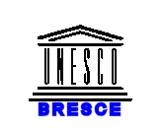


INTERNATIONAL
HYDROLOGICAL
PROGRAMME

BRESCE

UNESCO/BRESCE “TRANSKARSTBA” Programme

Internationally Shared Aquifers in the Balkan Region

Transboundary Karst Aquifers

FINAL REPORT

June 2007

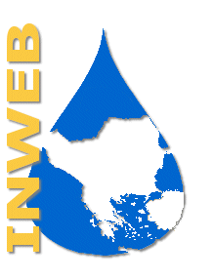


Prepared by
Unesco Chair and Network INWEB/Aristotle University of Thessaloniki, Greece

CONTENTS

1. Introduction

2. General Scope and Methodology

2.1 Geographical, Topographical and Political Scope
2.2 Hydrographical, Hydrological and Hydrogeological Scope
2.3 Karst Geology and Karst Aquifers in the Balkans

2.4 Methodology and Inventory of Karst Transboundary Aquifers

- Development of an Internet-based GIS database

  - INWEB’s new WEB site
  - Water Database

- Conclusions and Recommendations

Annex 1 Data Compilation
Annex 2 Compiled Information

- Introduction
In early 2003 UNESCO's Regional Office for Science in Europe (BRESCE) (Venice) initiated with the UNESCO Chair/INWEB, Thessaloniki, Greece, a collaborative action project on transboundary waters in the Balkans called “Assessment and Management of Transboundary Water Related Risks in the Balkans” (TRANSRISKBA). One of the main results of TRANSRISKBA was the development of regional inventories of internationally shared waters in South East Europe (SEE). For transboundary karst aquifers, this was achieved by the cooperative project “Managing Transboundary Karst Aquifers in the Balkans” (TRANSKARSTBA), which was based on the results and recommendations of TRANSRISKBA concerning the transboundary karst.

Groundwater aquifers, especially in karst areas and populated regions, are the most precious of water resources and have specific and special needs for their use, protection and management. Transboundary karst aquifers are very important water-supply resources in SEE, especially along the Adriatic Sea and the Mediterranean coastal areas. They are mainly linked with mountainous areas where anthropogenic activities and pollution sources are very limited. This means that in many cases karst aquifers contain very clean and healthy groundwater. However, karst aquifers are highly vulnerable to pollution, and in transboundary areas it is vital to harmonise the criteria for the definition of protection zones and what protection and management measures should be taken.

The TRANSKARSTBA project focused on internationally shared karst aquifers in the Balkans. In its scientific approach the project took interdisciplinarity into account and also considered the variety of stakeholders concerned with a range of specific problems related to groundwater management and environmental risks in SEE. More specifically the project achieved the following results:

- Revision and update of inventories on internationally shared surface and groundwaters in SEE
- Development on the WEB of a special site on transboundary karst aquifers in SEE, including country information and data
- Setting of priorities for local cooperative studies and formulation of a project on transboundary karst.

As a continuation and output of TRANSKARSTBA a major regional cooperative project was formulated and submitted to the Global Environment Facility (GEF) for funding, named DiKTAS (Dinaric Karst Transboundary Aquifer System). The main objective of DiKTAS, which remains in GEF’s pipeline, is to help Balkan countries establish a regional cooperation mechanism for integrated management of karst water and land resources. The fragmental distribution of karst aquifers across political boundaries and the differentiation between river basins and karst hydrogeological units mean that cooperation and mutual understanding are very important factors for sustainable development and environmental protection in the region.

As an extension of the TRANSKARSTBA project, the present work aims to provide support to DiKTAS by incorporating additional information from the SEE countries concerning transboundary aquifers and using new Internet-based technologies, like Google Earth and Map Server, to disseminate information and foster cooperation between SEE countries.

The present work is also part of the UNESCO-ISARM programme for the Balkans. UNESCO, and more specifically UNESCO's International Hydrological Programme (IHP) (Paris), having recognised that transboundary aquifer systems are important sources of fresh water in many regions of the world, decided to launch an initiative called the Internationally Shared Aquifer Resources Management programme (ISARM) to promote studies on transboundary aquifers in different regions of the world. The UNESCO-ISARM/Balkans programme aims at improving understanding of scientific, socio-economic, legal institutional and environmental issues related to the management of transboundary aquifers in the region. The programme operates through a joint coordination committee of experts from UNESCO IHP, the International Association of Hydrogeologists (IAH), the Food and Agriculture Organisation of the United Nations (FAO) and the United Nations Economic Commission for Europe (UNECE).

For the work reported here, INWEB cooperated closely with UNECE, and especially with the Working Group on Monitoring & Assessment, Switzerland. UNECE had previously developed a European inventory of shared aquifers, which included only very limited information from SEE. After the collapse of the Former Yugoslavia, the situation in the Balkan region became very complicated because of new political borders and the resulting multitude of new transboundary aquifers. UNECE, together with the British Geological Survey, prepared a questionnaire on transboundary aquifers and sent it to all member states of the region by June 2006. The responses to this questionnaire have been incorporated in the present study.

A coordination workshop for all parties involved in the present work, namely UNECE, UNESCO ISARM, UNESCO BRESCE, UNESCO Chair and Network INWEB and IGRAC (International Groundwater Assessment Centre, The Netherlands), was organised in Thessaloniki from 23rd-24th April 2007, entitled:

Transboundary Groundwaters in SEE: Assessment and Future Perspectives

From the discussions and exchange of views it become clear that although all involved partners deal with the same topic of transboundary aquifers, their scope and objectives are different:

- UNECE by its mandate to the member states aims mainly to formulate an assessment of the current situation regarding the pressure factors on groundwater bodies and to provide information on status, trends and impacts in relation to both quantity and quality as well as on the management measures being taken, planned or needed to prevent, control or reduce transboundary impacts in shared groundwaters in the region.
- UNESCO partners, namely UNESCO/IHP, Paris; UNESCO/BRESCE, Venice, UNESCO/INWEB and IGRAC aim to develop capacity building, shared databases, and scientific methodologies and tools such as GIS mapping, modelling and remote sensing, in order to help countries cooperate through interdisciplinarity and stakeholder participation.

The workshop had two main objectives: Firstly to review and finalise the assessment of transboundary groundwaters in SEE, and secondly to identify possible follow-up activities concerned with transboundary groundwater resources management in the region. The first objective concerns the UNECE mandate to its members, while the second one is part of the common missions of both UNESCO and UNECE regarding the development of pilot projects and strengthening cooperation between riparian countries.

The new data as well as the results and recommendations of this workshop have been taken into account in this report. Also developments concerning the Internet-based GIS interactive database powered by Google Earth and recommendations for future actions are described in this final report.

Acknowledgments

Basic information and data were provided by the following national experts, most of whom are members of UNESCO Chair and Network INWEB:

- Dr. Rossitza Gorova, Executive Environment Agency, Ministry of Environment and Water, Sofia, Bulgaria
- Eng. Ventcislav Nikolov, Director of the Basin Directorate in Black Sea Region, Varna, Bulgaria
- Eng. Ivailo Tcankov, expert Basin Directorate in Danube Region, Pleven, Bulgaria
- Dr. Lidija Globevnik, University of Ljubljana, Faculty of Civil and Geodetic Engineering, Ljubljana, Slovenia
- Prof. Dr. Sevket Cokgor, Istanbul Technical University, Faculty of Civil Engineering, Istanbul, Turkey
- Mr. Nijaz Lukovac, Hydro-Engineering Institute, Sarajevo, Bosnia & Herzegovina
- Prof. Dejan Ljubisavljevic, University of Belgrade, Faculty of Civil Engineering, Belgrade, Serbia & Montenegro
- Prof. Cvetanka Popovska, University of Ss. Cyril and Methodius, Faculty of Civil Engineering, Skopje, Former Yugoslav Republic of Macedonia
- Dr. Manjola Banja, Hydrometeorological Institute, Tirana, Albania
- Asst. Prof. Davor Malus, University of Zagreb, Zagreb, Croatia
- Prof. Dr. Boris Mijatovic, NKIAH Committee of Serbia and Montenegro, Serbia and Montenegro
- MSc Saša Milanović, Faculty of Mining & Geology, University of Belgrade, Belgrade, Serbia
- Mr. Goran Jelavić, Vodno područje slivova Jadranskog mora, Mostar, Bosnia & Herzegovina
- Dr. Ivana Starčevića, Vodno područje slivova Jadranskog mora, Mostar, Bosnia & Herzegovina
- Mr. Damir Mrđen, Vodno područje slivova Jadranskog mora, Mostar, Bosnia & Herzegovina
- Mr. Ivan Antunović, consultant, Vodno područje slivova Jadranskog mora Mostar, Bosnia & Herzegovina
- Dr.eng. Mihai Bretotean, National Institute of Hydrology and Water Management, Bucharest, Romania

2. General Scope and Methodology

2.1 Geographical, Topographical and Political Scope
The Balkan Peninsula lies in South-East Europe, covers an area of around 520,000 km² and has about 45 million inhabitants (Fig.1).

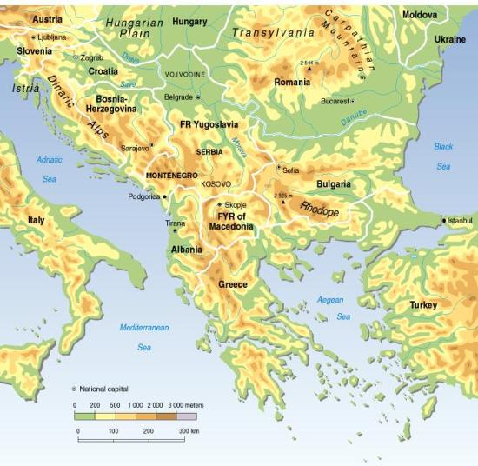

Figure 1. Topographical and political map of the Balkan region.

The “Balkan region” is defined for the purpose of this study as the area south of the Sava River sub-basin (starting west of Ljubljana) and further downstream south of the Danube River, i.e. including the territories of Romania and the Meric-Ergene sub-basin in Turkey. This means that the following countries are involved:
- Slovenia (from the line Triest – Ljubljana eastward but south of the Sava River)
- Romania
- Croatia (the region south of the Sava River up to the Adriatic coast, but not the islands)
- Bosnia & Herzegovina (the region south of the Sava River up to the Adriatic coast)
- Serbia
- Montenegro
- Former Yugoslav Republic of Macedonia
- Albania
- Greece (only the mainland)
- Bulgaria
- Turkey (the European part of the country)

2.2 Hydrographical, Hydrological and Hydrogeological scope
2.2.1 Hydrographical characteristics
The Balkan Peninsula is divided in several hydrographic units, belonging to the Adriatic, Aegean and Black Sea catchments. In the south, a multitude of river basins belong to the Mediterranean Sea catchment (Fig.2). These are the non-Danubian River Basins shown in Fig. 2.
The northern part of the Balkan region belongs to a single hydrographic unit, which is the Danube River Basin (Fig.3). As shown in Fig.3, the Danube River Basin is part of the Black Sea catchment.

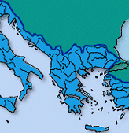

Figure 2. Balkan part of the Mediterranean Sea catchment (non-Danubian River Basins).
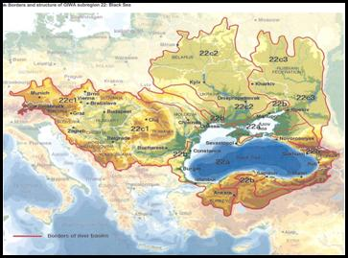
Figure 3. Balkan part of the Black Sea catchment (part of Danube River Basin).

2.2.2 Hydrological characteristics
The climate in the Balkans ranges from humid to arid depending on the distribution of precipitation (Fig. 4). Yearly average precipitation is more than 2.000 mm in the mountainous areas from the Alps in the west and the Dinaric Mountain and Pindos Mountain in the south. The central part of the Balkan Peninsula, from the Pannonian plain in the north to the Thessalia plain in the south is semi-arid, with less than 600 mm precipitation a year. The Balkan and the Rhodopi Mountains in the central peninsula have more than 1.000 mm per year. The eastern part on the Black Sea coast is semi-arid.

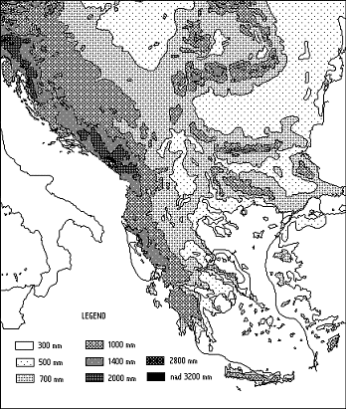

Figure 4. Mean annual precipitation in the Balkan region [WMO].
2.3 Karst Geology and Karst Aquifers in the Balkans
Karstification is the geologic process near the Earth´s surface of mechanical and chemical erosion and dissolution by water on soluble rocks, such as limestone, dolomite or gypsum. Karstification is developed best on thick, fractured, and pure limestones in a humid climate. The resulting karst morphology is usually characterised by dolines (sinkholes), hums (towers), caves and a complex subsurface drainage system. Karst geological areas in Europe are shown in Fig. 5.

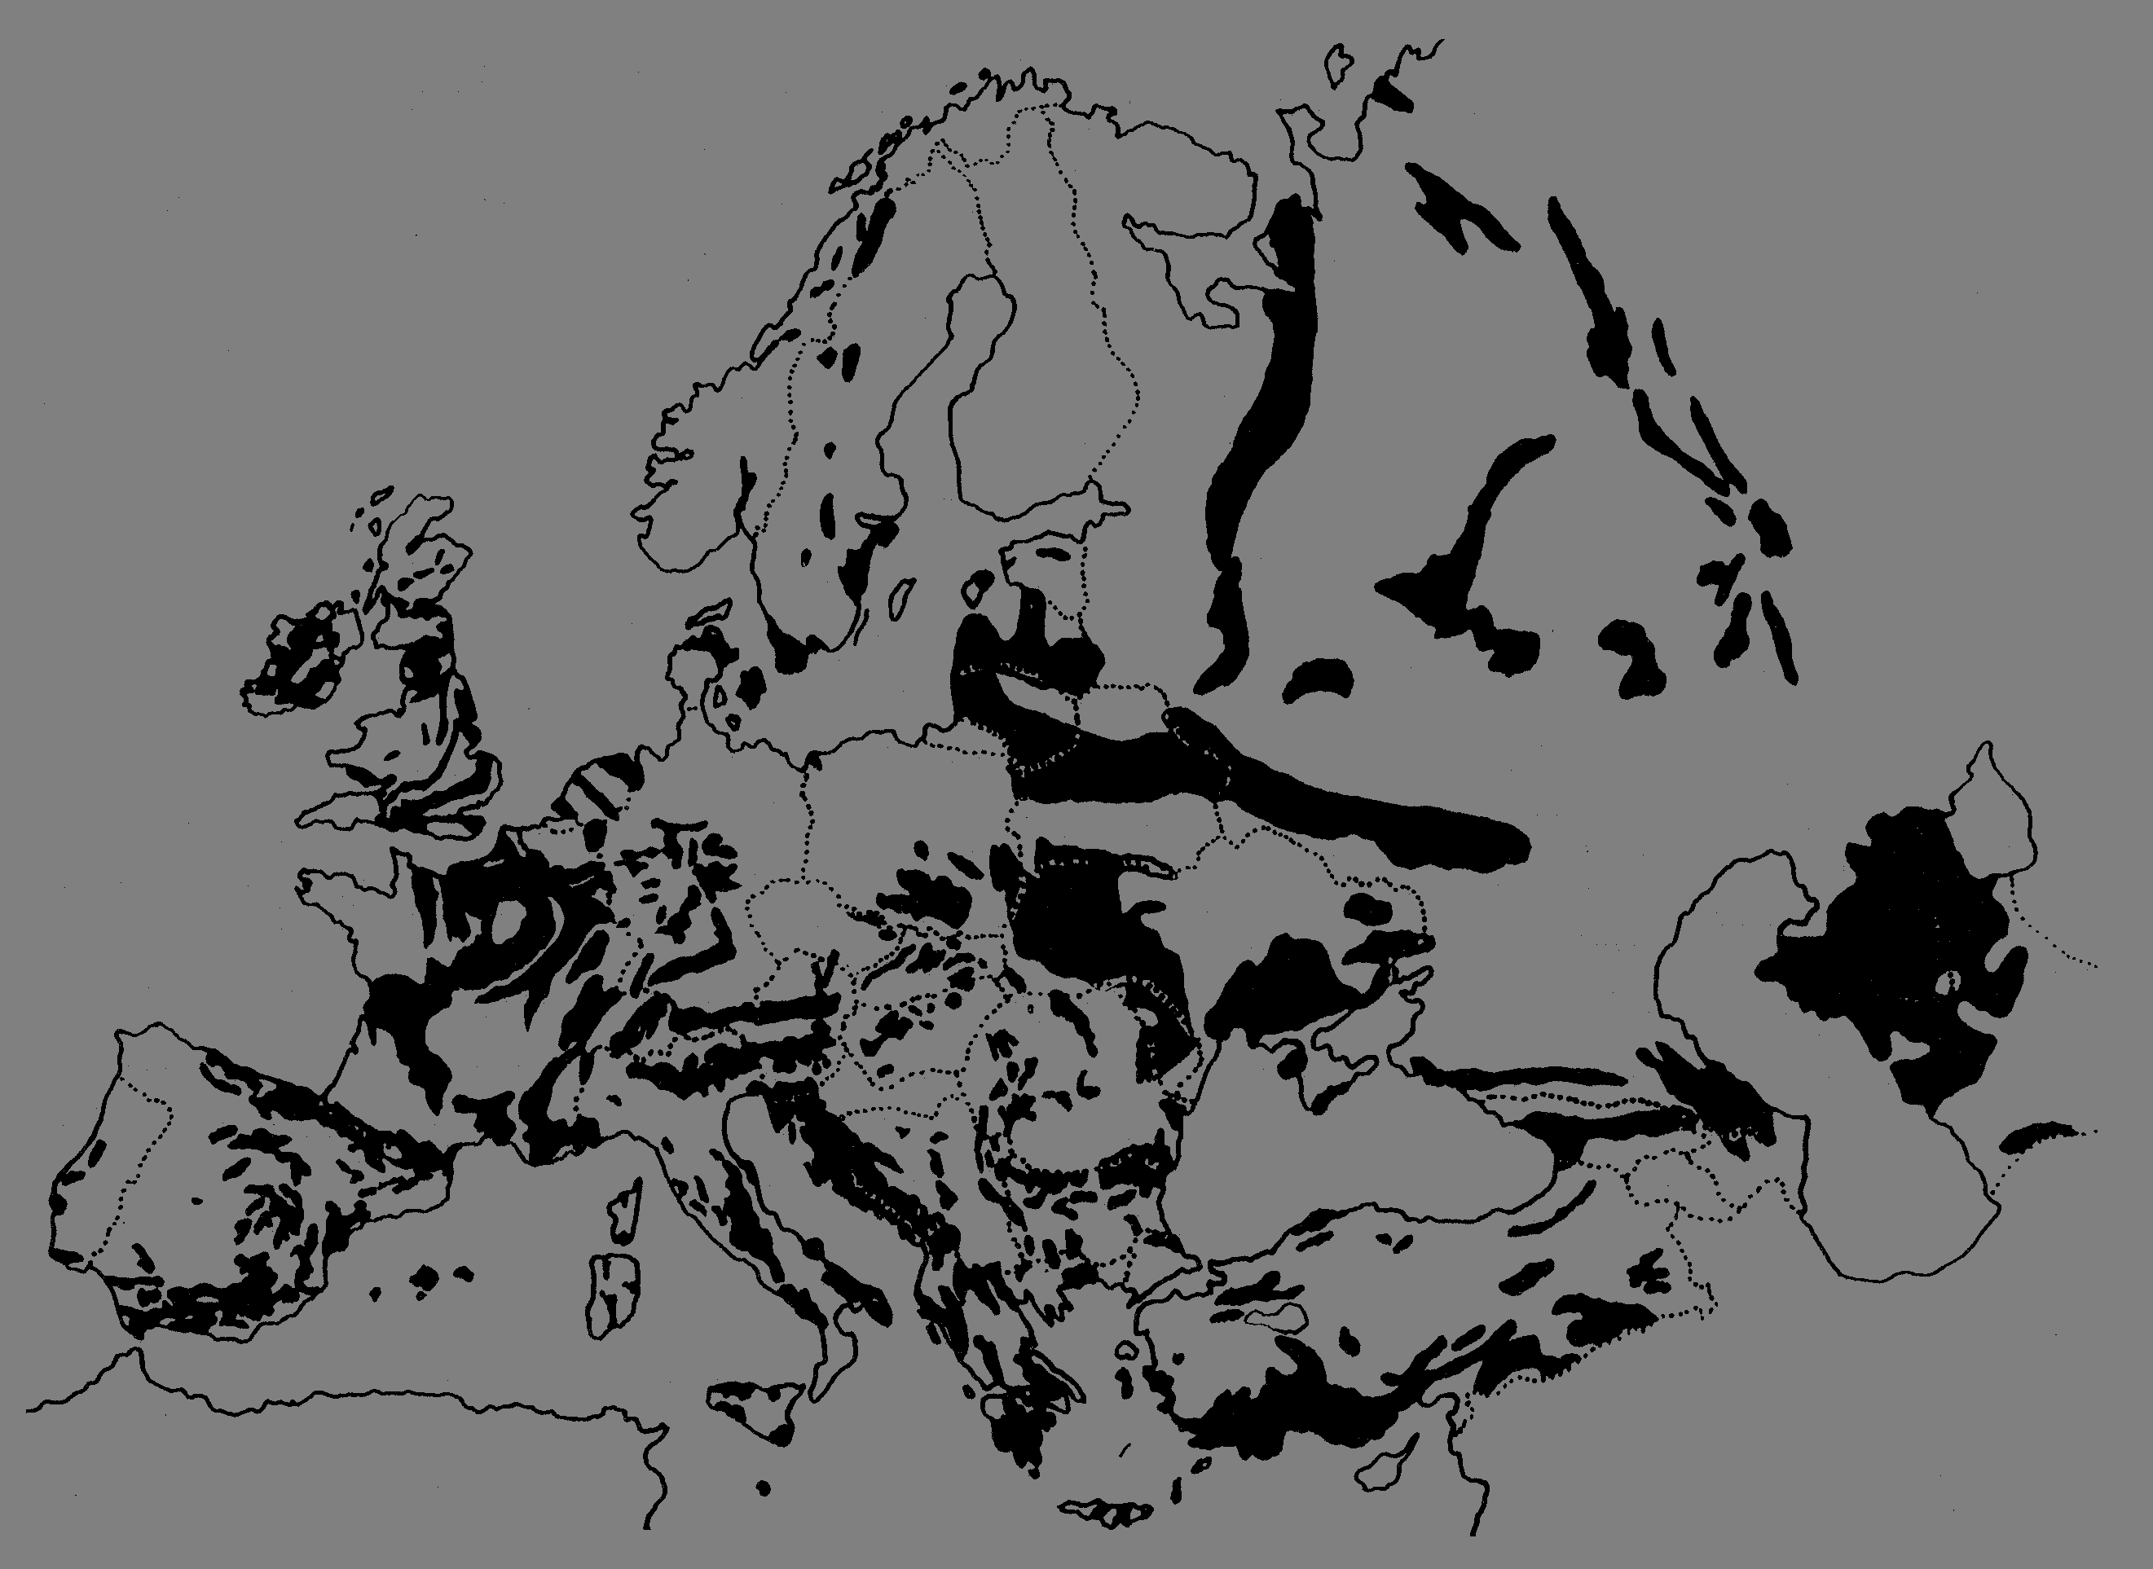
Karst Areas
in SEE

Figure 5. Karst areas in Europe and the Balkan region [EU COST 65].

Karst aquifers are formed by solution processes from rainwater that increase the permeability of limestones and dolostones. Karstic phenomena create subterranean fractures and water conduits of high permeability. In karstic regions surface runoff is almost nil and large volumes of groundwater can be found at various depths.
Almost half of the Balkan region is karst (Fig.5). Major aquifers have formed in these karstic formations, with caves, stalactites and stalagmites of great natural beauty, some of which have been included in the list of UNESCO’s natural heritage sites.
The most important karst aquifers of the region are located along the Adriatic coast in the mountainous area of the Dinarides. This chain of high mountains is the continuation of the Alpic ring in central Europe (the Alpes or Alpides). Almost half of the water from the mountainous area of Dinarides disappears underground in karst formations and flows in the shortest direction to the Adriatic Sea. The rest of the water drains via the Danube River towards the Black Sea.
The name karst is associated with the region of the Former Republic of Yugoslavia now occupied by Slovenia, Croatia, Bosnia & Herzegovina and Serbia & Montenegro. In fact the name karst derives from the Slav word “Kras”, which is the name of a region located in western Slovenia, north of the city of Trieste (Fig.6). The Indo-European word “kar” means stone and indeed the region is a stony barren plateau dominated by limestone rocks (Fig.7).

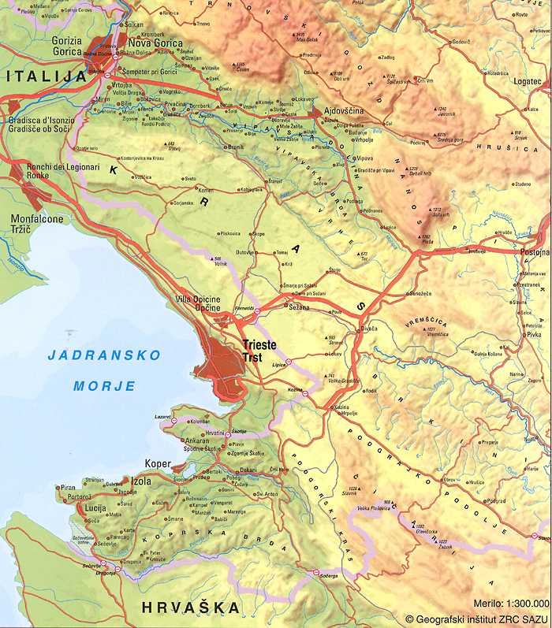

Figure 6. Location of the Kras region in western Slovenia.

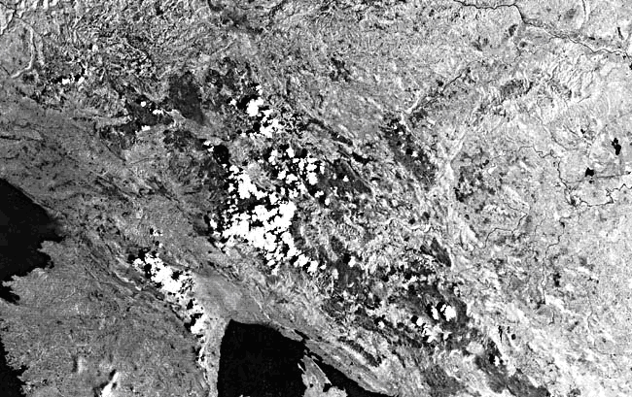

Figure 7. Part of Landsat image 3009-09094-7, June 8, 1978, showing the karst topography in the Slovenian Dinaric Mountains.

As shown in Fig. 8, transboundary karst aquifers in the Balkans are found in 4 different areas:
- The Dinaric karst (Dinarides Mountains: divided in outer and inner Dinarides)
- The Hellenic karst (Hellenides Mountains: the Pindos chain)
- The Carpatho-Balkan karst (Carpatho-Balkanian geotectonic unit)
- The South-Balkan karst (Rhodopi Mountains), and
- The Eastern Balkan karst (along the Black Sea coast).

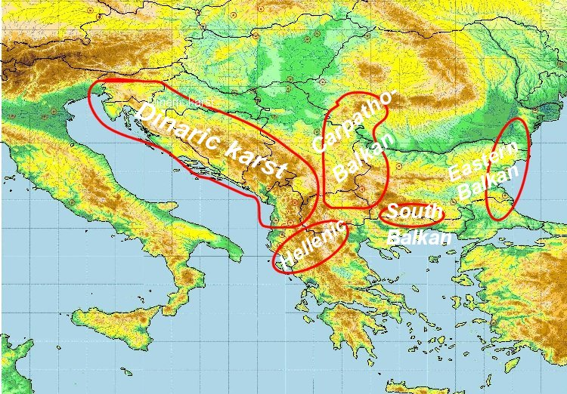

Figure 8. Karst areas in the Balkans where transboundary aquifers are located.

2.4 Methodology and Inventory of Karst Transboundary Aquifers

In the case of internationally shared surface waters much progress has been made on how to determine what type of water resources problems need or will need to be resolved by bilateral or multilateral interstate agreements. A large number of such international agreements (more than 200 during the last 50 years) have been signed to resolve various types of interstate surface water resources problems. These are available for reference and act as precedents.

The situation is quite different in the case of internationally shared groundwater aquifer resources. Difficulties arise in scientific and technical matters (groundwater monitoring, data interpretation and modelling), and because of a lack of political willingness for cooperation and the weakness of the institutions involved. Major difficulties arise in designing groundwater development plans because groundwater flow and groundwater quality are subject to several types of uncertainties and are affected by these to a much greater degree than in surface water hydrology. These uncertainties are related to the high variability in space and time of the hydrogeological, chemical and biological processes. The principal challenge is to set up a cooperative framework between countries involved, so that institutions from both sides can work together effectively (Ganoulis et al., 1996).

In many real situations interactions between surface and groundwaters on both sides of the international border may create international disputes. As shown in Fig. 9 (UNESCO/ISARM, 2001) groundwater over-pumping on one side of the boundary may lower the water level of a shared surface lake or river or accelerate the sea water intrusion in a coastal zone located in the other country.

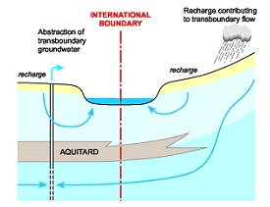

Figure 9 Interaction between transboundary surface and groundwater flows.

A very characteristic case of groundwater-surface water interdependencies can be found in the southern Balkans, in the region of the Doirani/Dojran Lake, which is internationally shared by Greece and the Former Yugoslav Republic of Macedonia (FYROM). In the many years of drought during the last decade, extensive evaporation together with over-pumping for irrigation purposes on the Greek side may have contributed to substantially lowering the lake’s water level. In all cases cooperation between countries is of primary importance in order to understand the problems, to agree about the underlying causes and to try to develop reliable solutions (see www.inweb.gr).

2.4.1 Typology of Transboundary Aquifers

Water infiltrating into the soil circulates through various geological formations. Depending on the boundary conditions (impermeable or semi-permeable layers of soil, atmospheric pressure, rivers and lakes) the groundwater forms various types of subsurface reservoirs, called aquifers. These are extensive permeable rock formations in which water partially accumulates and through which water partially flows. Fig. 10 gives an overview of different types of groundwater aquifers in various geological formations. According to their geological formation characteristics, aquifers may be classified in 3 main groups:

- Alluvial and sedimentary aquifers
- Limestone and karstic aquifers
- Crystalline fractured aquifers.

(1) Sedimentary and alluvial aquifers: This category of aquifers is characterised by successive layers of different hydrogeological properties: permeable, semi-permeable or impermeable. The water circulates in the successive layers, which consist mostly of gravel, sand, clay and silt. Phreatic, confined or semi-confined (leaky) aquifers are formed.

(2) Limestone and karstic aquifers: Solution processes caused by acidified rainwater increase the permeability of limestones and dolostones forming secondary aquifers. Karstic phenomena are extreme cases of such processes, creating subterranean fractures and water conduits of high permeability. In karstic regions surface runoff is almost nil and large volumes of groundwater can be found at various depths.

(3) Crystalline rock aquifers: The importance of groundwater resources in these rocks depends on two factors (a) the rate of fracturing and (b) the chemical weathering of the surface layer, through which precipitation water percolates into the rock. This geological formation is divided in several blocks by secondary and primary fractures.

Figure 10. Groundwater in various geological formations (Bodelle and Margat, 1980).

In transboundary situations, depending on the location of the international border, sedimentary and alluvial aquifers may be classified in four different types, as follows: (Fig. 11, Chilton, personal communication, 2007)

Type (a): the state border follows the basin and groundwater divide. Very limited discharge occurs across the border.
Type (b): the state border is separate from the basin and groundwater divide. Recharge occurs in one country and discharge in the other one.
Type (c): the state border follows a transboundary river or lake. Little transboundary groundwater flow occurs in the alluvial aquifer connected to the river.
Type (d): Large deep aquifer, recharged far from the border. Transboundary groundwater flow not connected to the surface may be important.

(a)

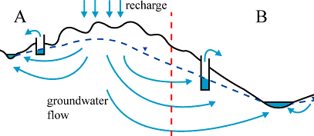
(b)
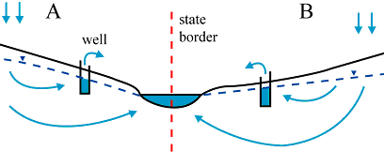
(c)
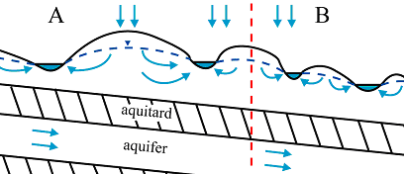
(d)

Figure 11. Types of transboundary sedimentary aquifers (Chilton, 2007).

In the case of deep karst aquifers covered by sediments, recharge of groundwater may occur in one country and water can appear at the surface in the form of a spring in another country (Fig. 12). This occurs frequently in the Dinaric karst (Western Balkans), between Bosnia & Herzegovina (upstream) and Croatia (downstream, near the Adriatic coast).

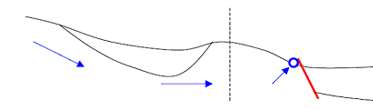
Sediments
Karst
Karst
Sedimentss
International Border
Spring

Figure 12. Large deep karst aquifer recharged in one country and forming a spring in a neighbouring country.

2.4.2 Transboundary Karst Aquifers in the Balkans

Transboundary karst groundwater aquifers provide 60 to 80 per cent of total water usage in their respective areas, and some of the Dinaric karstic aquifers of Bosnia, Serbia, Croatia, Montenegro and Albania as much as 90 or even 100 per cent. In terms of numbers, the importance of transboundary karstic aquifers is shown in Figs. 13 and 14.

Figure 13. Distribution by country of the total number of transboundary
and karst transboundary aquifers in SEE.

Figure 14. Distribution by country of karst transboundary aquifers (as % of the total) in SEE.

The following subjects were addressed and included in two questionnaires.
Please note that information included in this inventory reflects experts’ opinions and is not the official position of national governments.

ISARM MEDITERRANEAN PROGRAMME
(UNESCO-FAO-UNECE–IAH)

QUESTIONNAIRE 1: TRANSBOUNDARY AQUIFERS IN THE MED REGION
Please complete using Word document format.
Please complete a separate questionnaire for each aquifer.
Please return by e-mail to: iganouli@civil.auth.gr with copies to: ShammyPuri@aol.com, a.aureli@unesco.org, bo.appelinvpl@flashnet.it by 27th June 2004.

- NAME OF THE TRANSBOUNDARY AQUIFER & COUNTRIES
Please give the name(s) of the shared aquifer and say which countries share it.

AQUIFER PROPERTIES

  - Geographical Properties
Please provide GIS (if available) or map.
- Approximate location of the aquifer according to your map. Please indicate what hydrographic basin it belongs to, province, department or any other detail that could be useful for location purposes.
- Shared international boundary length (km)
- Aquifer type
- Areal extent (km²⁾ - population resident in this area (if known)
- Topography, including altitude range (m)
- Geology & principal land use

2.2 Hydrogeological Characteristics and Groundwater
Please provide principal hydrogeological information, and if appropriate insert Excel tables into the Word document:

- Hydrogeology
- Rainfall, average annual and seasonal distribution etc.
- Recharge / discharge area
- Level changes (m/yr) – natural, induced by pumping, or other reasons
- Total available annual groundwater resources (Mm³/y)
- Total groundwater abstractions (Mm³/y) (estimated where not measured)
- Flow in/out across national boundary (Mm³/yr)
- Groundwater flow direction and gradient across boundary
- Water uses (total, by sector, principal uses, current - estimated and future - projected)
- Deficits and other resource concerns (e.g. quality, extremes, environmental degradation, interactions with surface water bodies / other aquifers)

- MONITORING DATA
Please note that stakeholders should comply with the WMO Resolution 25 on international exchange of hydrological and related data. (http://www.wmo.ch/index-en.html). If appropriate insert Excel tables into the Word document in order to provide information and available data on quantity, quality, transparency and accessibility, including:
- Observation networks
- Maps, with available scales, GIS and remote sensing imagery
- Data archives and their adequacy
- Research centres

3.1 Quantity
- Nº. of monitoring stations
- Frequency of measurements
- Water levels
- Additional information

3.2 Quality
- Nº. of monitoring sites
- Frequency of measurements
- Nitrogen compounds
- Major ions
- Heavy metals
- Pesticides
- Industrial organic compounds

- SIGNIFICANT ISSUES AFFECTING THE AQUIFER SYSTEM
Please list the significant issues that relate to the shared aquifer resources:
- Water resources
- Ecology of any water courses / wetlands / other
- Human development / poverty issues / economic development
- Other

- POLICY AND LEGISLATIVE PROPERTIES

- National regulations that apply to aquifers: e.g. licenses for production, any statutory reporting, any controls on drilling, use of the water, etc.
- Groundwater ownership, rights etc.
- Formal international agreements ratified
- Informal agreement/conventions
- Key institutions national level – local level

- NAME AND CONTACT DETAILS OF PERSON(S) COMPLETING THIS FORM:
UN/ECE Working Group on Monitoring and Assessment

ASSESSMENT OF TRANSBOUNDARY GROUNDWATERS:
QUESTIONNAIRE

Country............................................ Aquifer...........................................

A. BRIEF DESCRIPTION OF THE TRANSBOUNDARY AQUIFER

1. Please look at the four simplified pictures below and indicate which of them most closely characterises your transboundary aquifer. If none, pleae provide a conceptual sketch of your transboundary aquifer in the blank box below.
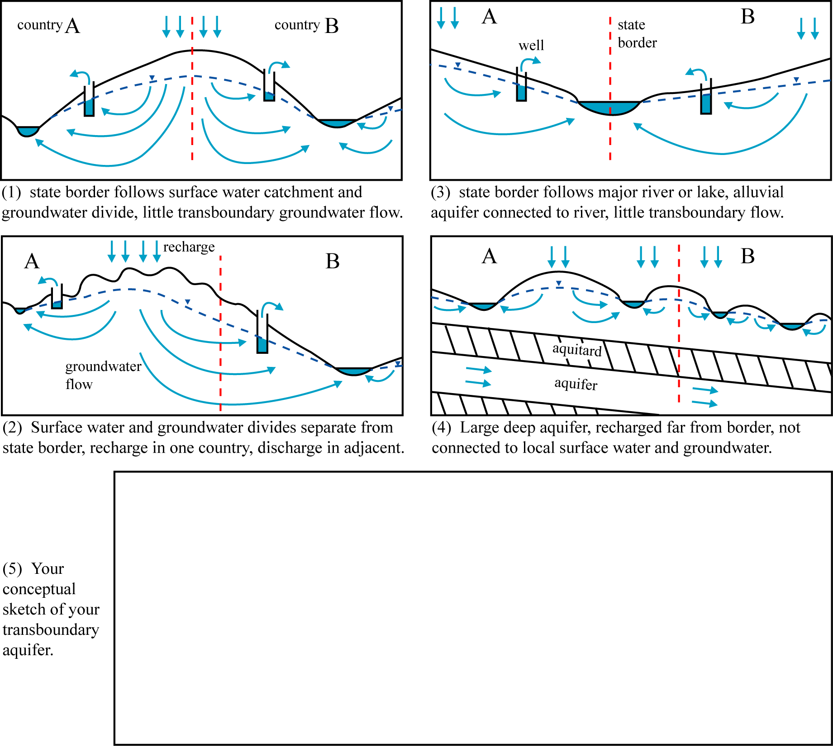

2. Indicate the general characteristics of the aquifer

a) Predominant lithology....................................................................................................
b) Thickness: mean (m)............. maximum (m)............... c) Areal extent (km²)............................
d) Dominant groundwater flow direction: from.. ........................... to ............................... (countries)
e) Link with surface water systems: strong □ medium □ weak □

3. Please provide a clear map of the transboundary aquifer, including aquifer boundaries and geographical coordinates. The map should preferably be supplied as a GIS-file.
B. IMPORTANCE OF TRANSBOUNDARY GROUNDWATERS

- Uses and Functions

Does the groundwater in this transboundary aquifer have direct uses and/or other functions?
No □ Why not? Irrelevant groundwater resource □
Problems with groundwater □
(if so, indicate these in section C)

or:
Yes □ Uses □ Groundwater as % of total water use ...........

Other functions □ Support of ecosystems □
Support of agriculture □
(directly from shallow water table)
Preventing land subsidence □
Maintaining baseflow and springs □
Seasonal heatstorage □

- Groundwater abstraction and use in the aquifer

Indicate in the table the percentage of total groundwater abstraction accounted for by each use

Type of use | Percentage | If you do not know the exact percentage, than mark one of the following options
Type of use | Percentage | < 25 % | 25 – 50 % | 50 – 75 % | > 75 %
Drinking water
Irrigation
Industry
Mining
Thermal spa
Livestock
Other (please specify)

Please indicate the year to which these figures apply................

C. WHICH PROBLEMS ARE OBSERVED IN TRANSBOUNDARY GROUNDWATERS?

1. Problems related to groundwater quantity

a) Specify if possible the average trend of groundwater level decline (m/year) ..................

b) Indicate in the table the type and scale of problem associated with groundwater abstraction from the aquifer

Problem | Increasing scale of problem
Problem | 1. Local and moderate | 2. Local but severe | 3. Widespread but moderate | 4. Widespread and severe
Increased pumping lifts or costs
Reduction of borehole yields
Reduced baseflow and springflow
Degradation of ecosystems
Sea water intrusion
Salt water upconing
Polluted water drawn into aquifer
Land subsidence
Other (please specify)

2. Problems related to groundwater quality

Indicate in the table the type, nature and scale of groundwater quality problems in the aquifer

Problem | Nature of problem |  | Typical range of concentrations | Scale, using classes 1-4 from table above
Problem | Natural origins | From human activities | Typical range of concentrations | Scale, using classes 1-4 from table above
Salinization
Nitrogen species
Pesticides
Heavy metals
Pathogens
Industrial organic compounds
Hydrocarbons
Other (please specify)

3. Evidence for transboundary effects

- Do you observe any decline of groundwater levels (or piezometric levels) caused or probably caused by activities in neighbouring countries?
Yes □ No □
- Do you observe any groundwater pollution caused or probably caused by activities in neighbouring countries?
Yes □ No □

D. TRANSBOUNDARY MANAGEMENT MEASURES

Indicate in the table which measures are presently being implemented or need to be applied

Management Measures | Already used and effective | Used, but Need to be improved | Need to be applied | Currently planned
Transboundary institutions (commissions, agreements, treaties, etc.)
Groundwater abstraction management by regulation (licensing, taxation)
Groundwater abstraction management by incentives or disincentives (subsidies, credits, energy prices, energy supply, etc.)
Increasing efficiency of groundwater use
Monitoring of groundwater quantity
Monitoring of groundwater quality
Public awareness campaigns
Protection zones for public supplies
Vulnerability mapping for land use planning
Good agricultural practices
Groundwater integrated into river basin management
Wastewater reuse or artificial recharge
Treatment of urban wastewater
Treatment of industrial effluents
Other (please specify)

2.4.3 Names of shared aquifers and overview map

Number | Aquifer name | Countries | Type
1 | Secovlje-Dragonja/Dragonja | Slovenia-Croatia | karstic
2 | Mirna-Istra | Slovenia-Croatia | karstic
3 | Opatija | Slovenia-Croatia | karstic
4 | Rijeka | Slovenia-Croatia | karstic
5 | Cerknica/Kupa | Slovenia-Croatia | karstic
6 | Radovic-Metlika/Zumberak | Slovenia-Croatia | karstic
7 | Bregana-Obrezje/Sava-Samobor | Slovenia-Croatia | alluvial
8 | Bizeljsko/Sutla | Slovenia-Croatia | alluvial
9 | Ormoz-Sredisce ob Dravi/Drava-Varazdin | Slovenia-Croatia | alluvial
10 | Mura | Croatia-Hungary | alluvial
11 | Drava/Drava West | Croatia-Hungary | alluvial
12 | Baranja/Drava East | Croatia-Hungary | alluvial
13 | West Serbia/Backa/Sava | Croatia-Serbia | alluvial
14 | Sava/Posavina | Croatia-Bosnia & Herz. | alluvial
15 | Kupa | Croatia-Bosnia & Herz. | karstic
16 | Una/Plesevica | Croatia-Bosnia & Herz. | karstic
17 | Krka | Croatia-Bosnia & Herz. | karstic
18 | Cetina | Croatia-Bosnia & Herz. | karstic
19 | Neretva right | Croatia-Bosnia & Herz. | karstic
20 | Trebisnjica/Neretva left | Croatia-Bosnia & Herz. | karstic
21 | Bileko Lake | Bosnia & Herz-Montenegro | karstic
22 | Dinaric litoral (west coast) | Montenegro- Croatia | karstic
23 | Dinaric east coast/Skadar/Shkodra lake | Montenegro-Albania | karstic
24 | Beli Drim/Drini Bardhe | Albania-Serbia | karstic
25 | Metohija | Montenegro-Serbia | alluvial
26 | Lim | Montenegro-Serbia | karstic
27 | Tara massif | Serbia-Bosnia Herzg. | karstic
28 | Macva-Semberija | Serbia-Bosnia Herzg. | alluvial
29 | Northeast Backa/Danube-Tisza Interfluve | Serbia-Hungary | alluvial
30 | Banat | Serbia-Romania | alluvial
31 | Miroc & Golubac | Serbia-Romania | karstic
32 | Dacian basin | Serbia-Romania | alluvial
33 | Timok | Serbia-Bulgaria | alluvial
34 | Stara Planina/Salasha Montana | Serbia-Bulgaria | karstic
35 | Nishava and Tran/Vidlic | Serbia-Bulgaria | karstic
36 | Zemen | Serbia-Bulgaria | karstic
37 | FYROM-SW Serbia | Serbia-FYROM | karstic
38 | FYROM-Central Serbia | Serbia-FYROM | alluvial
39 | Tetovo-Gostivar | Serbia-FYROM | karstic
40 | Korab/Bistra - Stogovo | Albania-FYROM | karstic
41 | Jablanica/Golobordo | Albania-FYROM | karstic
42 | Ohrid Lake | Albania-FYROM | karstic
43 | Mourgana Mountain/Mali Gjere | Albania-Greece | karstic
44 | Vjosa-Pogoni/Nemechka | Albania-Greece | karstic
45 | Prespes and Ohrid Lakes | Albania, Greece & FYROM | karstic
46 | Galicica | Greece-FYROM | karstic
47 | Pelagonia/Florina/Bitolsko | Greece-FYROM | alluvial
48 | Gevgelija | Greece-FYROM | alluvial
49 | Dojran Lake | Greece-FYROM | alluvial
50 | Sandansky-Petrich | Bulgaria, Greece & FYROM | alluvial
51 | Gotze Dedlchev/Orvilos-Agistros | Greece-Bulgaria | karstic
52 | Nastan-Trigrad | Greece-Bulgaria | karstic
53 | Smolyan | Greece-Bulgaria | karstic
54 | Rudozem | Greece-Bulgaria | karstic
55 | Erma Reka | Greece-Bulgaria | karstic
56 | Svilegrad Stambolo/Orestiada | Bulgaria, Greece & Turkey | alluvial
57 | Evros/Meric | Greece-Turkey | alluvial
58 | Topolovgrad massif | Bulgaria & Turkey | karstic
59 | Malko Tarnovo massif | Bulgaria & Turkey | karstic
60 | Pleistocene Someş/Szamos alluvial fan | Romania-Hungary | alluvial
61 | Pleistocene Mureş/Maros alluvial fan | Romania-Hungary | alluvial
62 | Lower Pleistocene somes alluvial fan | Romania-Hungary | alluvial
63 | Middle Sarmantian Pontian | Romania-Moldova | alluvial
64 | Neogene-Sarmatian | Romania-Bulgaria | alluvial
65 | Upper Jurassic – Lower Cretaceous | Romania-Bulgaria | alluvial

Overview Map of Transboundary Aquifers in the Balkan Region
3. Development of an Internet-based GIS database
3.1 INWEB’s New WEB site

3.1.1 Home page

INWEB’s internet site (www.inweb.gr) shows various logos on its home page: firstly that of the UNESCO Chair and Network INWEB, secondly that of UNESCO, and thirdly the logo of the Aristotle University of Thessaloniki, which is the hosting institution of this UNESCO Chair. The political map of the Balkans emphasises the importance of networking and cooperation by linking the main cities where INWEB’s focal points are located.

In order to facilitate the hosting of the new transboundary aquifer database, INWEB’s website had to be completely modified. The overall aim was to provide users with:

- an easy and user-friendly tool combining state of the art map server technologies like Google Map and Google Earth with up-to-date databases containing highly detailed scientific data on transboundary aquifers in the Balkans
- flexibility
- search options based on user-defined criteria

As shown in Fig. 15, there are 5 general menus:

- INWEB presentation
- Activities (UNESCO and other projects, Education and Training, Workshops)
- Water Database (including the Google Earth powered data base)
- Further Information (INWEB Documents, Links)
- News

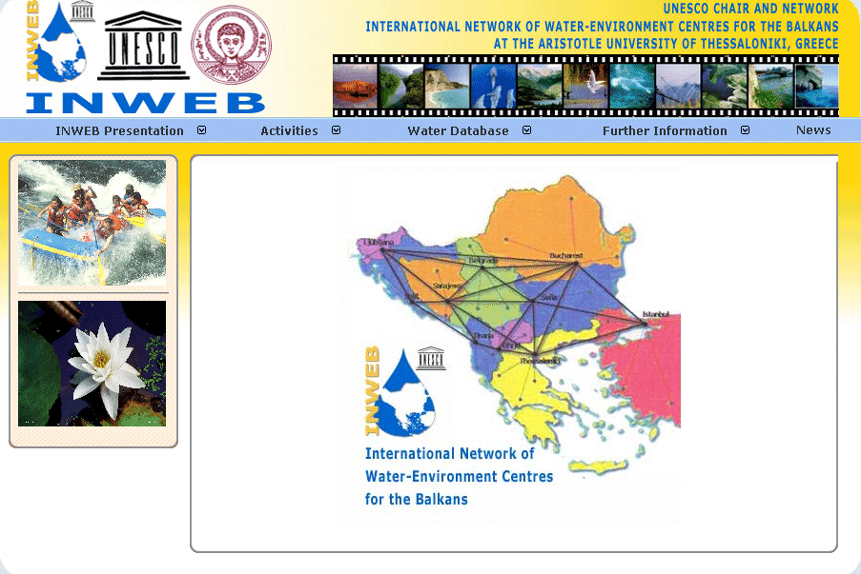
Figure 15. Home page of INWEB's new WEB site.

3.2 Water Database

This opens two sub-menus (see Fig. 16):

- Transboundary Aquifers
- Internationally Shared Surface Waters (not further elaborated in this report)

    - Transboundary Aquifers
This opens a further 3 sub-menus (see Fig.16):

- Interactive Map
- Aquifers Database
- Descriptive Information

Each of these three further sub-menus is described in detail below:

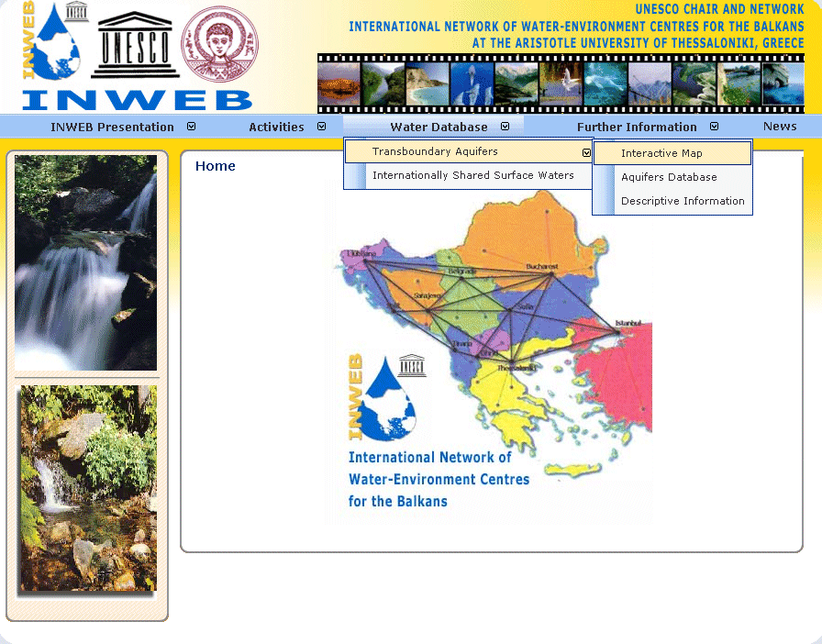
Figure 16. Sub-menus in Water Database.

3.2.1 Interactive Map

An interactive map is one that can be dynamically changed. An interactive map is based on the logic of the internet map service, and is a map that is published on the internet. It may contain a single GIS dataset (e.g. satellite imagery, rivers, roads or land use) or a collection of several GIS datasets. Map services allow users to access GIS data directly over the web just like any other local data set. This makes the sharing of GIS data easier and much more flexible. Nowadays, map service technology has been dramatically improved by the development of Earth browsers such as Google Earth and Google Maps, which make the presentation of interactive maps very attractive, exciting and user-friendly.

INWEB's interactive map is a Google Map based application combined with GIS technology. By clicking on the arrows and symbols, this map allows users to pan (move) up/down/left/right and to zoom in/out on a political map of the Balkan region, which shows all transboundary aquifers marked with ellipses. The ellipses in green refer to karst aquifers, and those in indigo to alluvial/sedimentary aquifers (see Fig. 17).

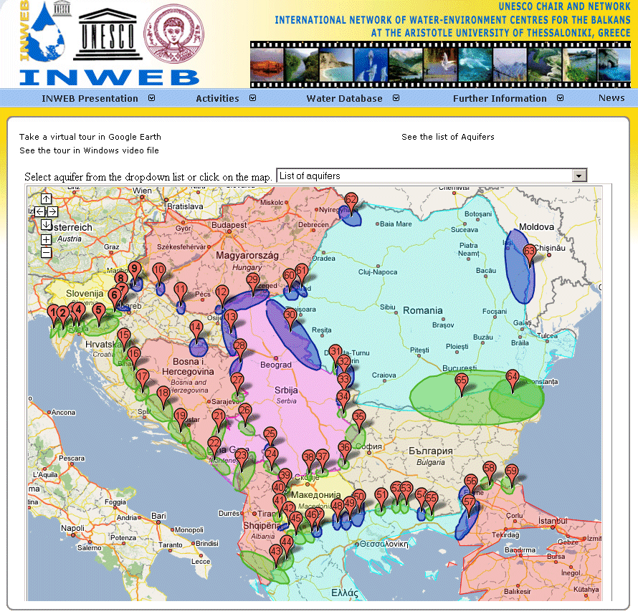
Figure 17. Interactive map

INWEB's interactive map offers users the following options:

Take a virtual tour in Google Earth
This activates the «transboundary surface water.kmz» which is a Google Earth KML file. KML files (a file format used to display geographic data in an Earth browser) use a tag-based structure with nested elements and attributes and are based on the XML standard. Google Earth then presents a tour of 20 locations in different river basins in the Balkans. By clicking one of these locations (marked in blue) Google Earth zooms in to the selected location.

See the tour in Windows video file
This gives the user the opportunity to watch a short video clip of the above-mentioned virtual tour in Google Earth. In this case however, the tour flies from one location to another automatically in the numerical order in which the locations are marked on the map.
See the list of Aquifers
This opens in a new window the complete list of the 65 transboundary aquifers in SEE.

Select aquifer from the dropdown list or click on the map
The map on the screen is a political map of the Balkans with all transboundary aquifers marked with ellipses. Those in green refer to karst aquifers, and those in indigo to alluvial/sedimentary aquifers. Each aquifer has a red tear-drop with the aquifer's reference number marked. There are three different ways to open further information on the aquifer:
- By clicking on the tear drop
- By clicking on the aquifer
- By selecting the aquifer name from the drop down list

All these ways open a balloon with the aquifer's name, the type of aquifer and the names of the countries to which the aquifer belongs (see Fig. 18). There are also two interactive links:
- More information (opens a new window with information on aquifer properties, hydrology, hydrogeology, water uses and policy)
- See the aquifer in Google Earth (activates Google Earth and zooms in automatically to this aquifer). The user has the option either to save this KML file to disk, or to open it. In both cases the user has the option of opening a new window with information on aquifer properties, hydrology, hydrogeology, water uses and policy (as above).

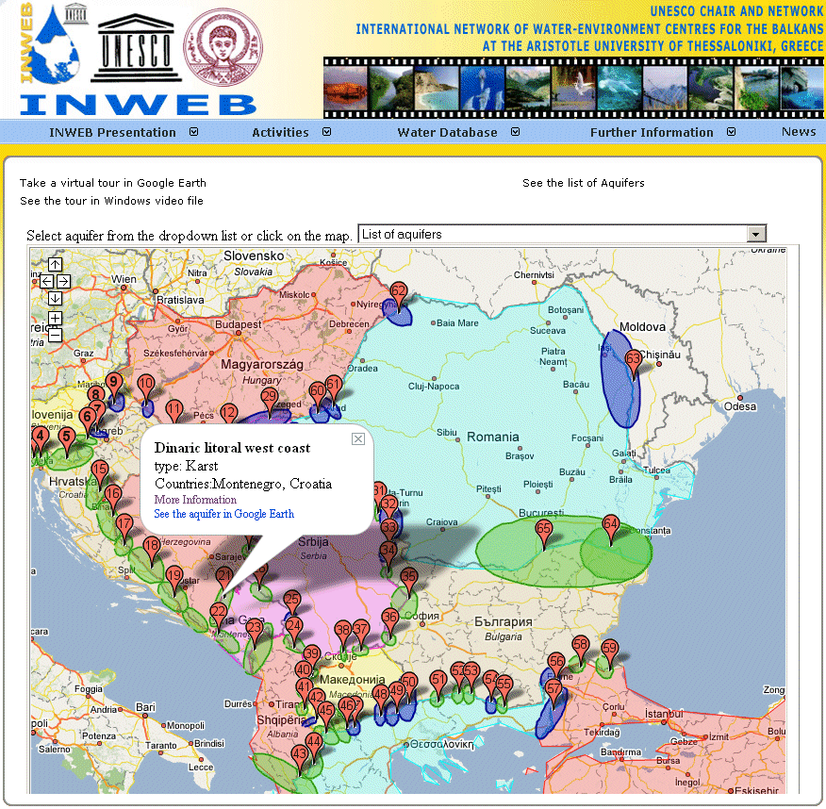
Figure 18. Interactive map: balloon

Example of aquifer attributes (ID 65, shared between Bulgaria and Romania)

Field Name | Romania | Bulgaria
id | 134 | 135
Aquifer ID | 65 | 65
Aquifer name | Upper Jurassic-Lower Cretaceous | Upper Jurassic-Lower Cretaceous
Countries | Romania, Bulgaria | Romania, Bulgaria
Country Name | Romania | Bulgaria
Aquifer Type | Karst | Karst
Boundaries Length (km) | 290 | 290
Area (km^2) | 11 | 15
Area Population (inh) | N/A | N/A
Altitude low (m) | 17 | N/A
Altitude high (m) | 250 | N/A
Topography description | "plateau 17- 250 m asl " | N/A
Mean annual Rainfall (mm) | N/A | N/A
Mean annual Rainfall Description | N/A | N/A
Discharge flow (m^3/s) | N/A | N/A
Annual groundwater resources (Mm^3/y) | N/A | N/A
Annual groundwater abstractions (Mm^3/y) | N/A | N/A
Water use Urban | 1 | 1
Water use Irrigation | 1 | 1
Water use Industrial | 1 | 0
Water use description | 70 % for drinking water supply, 15% each for irrigation and industry | 25-50% for drinking water supply, <25 % for irrigation
Pressure Factors |  | Agriculture
Quantity Problems | Local and moderate increased pumping lifts | Local but severe increased pumping lifts
Quality Problems | None mentioned | Local and moderate concentrations (30
Transboundary Impacts | None | None for quantity or quality
Management Measures | No management measures reported as being in use, a range of measures is currently planned | Groundwater abstraction regulation already used and effective, transboundary institutions, monitoring of groundwater quantity and quality, protection zones, vulnerability mapping, good agricultural practices and wastewater and effluent treatment used but need improvement, exchange of data is needed
Needs
Future Trends
Notes
Policy Bilateral agreements | N/A | N/A
Policy Regional agreements | N/A | N/A

    - Aquifers Database

INWEB's aquifer database contains data on internationally shared aquifers in the Balkans. The dataset is the same as that presented in the Interactive Map, but in a different format. Three filters shown in dropdown menus can be selected individually or combined with a logical AND with the other active filters. The three filters are:

- Aquifer name
- Country name
- Aquifer type

For example by selecting Greece from the Country Name drop down menu, a list of all aquifers shared by Greece and one or more other countries is automatically produced. If this selection is combined with a second filter e.g. Aquifer Type – Alluvial, a list showing only the alluvial aquifers shared by Greece and one or more other countries is automatically produced. If the Aquifer Name is selected from the drop down menu, this selection can be combined with a selection from the Country Name drop down menu to produce a list showing only the data relevant to that particular Aquifer and Country.

    - Descriptive Information

The map on the screen shows the transboundary aquifers in SEE. By clicking on the indigo (alluvial/sedimentary aquifers) and green ellipses (karst aquifers) the user can access a descriptive HTML text, which presents the complete set of information provided by the country experts in response to the questionnaires.
4. CONCLUSIONS AND RECOMMENDATIONS

Transboundary groundwater protection plans and sustainable management of shared groundwater resources in the Balkan region should be based on strong cooperation between countries involved, and joint projects should be developed. Of primary importance are:

- development of common monitoring systems
- sharing of data
- establishment of multi-lateral and multi-disciplinary aquifer commissions
- development of common research projects with harmonised methodology

For karst transboundary aquifers, which are very important in the region, the main difficulties are related to the following:
- karst aquifers are heterogeneous with anisotropic surface and underground formations; and have well developed, complex, deep and unknown underground karst conduits, fissures, joints and cracks
- a strong interaction exists between the circulation of surface water and groundwater; and between inflow (ponors) and outflow (karst springs)
- there are significant and rapid variations in groundwater level
- the influence of man's induced structures and activities is important (dams, reservoirs, etc.).

The main long-term goal of the TRANSKARSTBA project is to:

Develop regional groundwater governance in order to ensure effective management of transboundary groundwater resources, taking into account environmental risks associated with various water pollutants and risks from potential conflicts over sharing transboundary aquifer resources.

In order to achieve this goal, and taking into account the results presented in this report, the following recommendations can be made for the GO-TRANSKARSTBA (Governance TRANSKARSTBA):

- Complete the actual inventory by including hydrogeological maps of transboundary aquifers
- Improve the Internet GIS-based database of transboundary aquifer resources in SEE
- Identify gaps and potential conflicts in groundwater national governance and also in bilateral and regional cooperation and coordination
- Establish a common knowledge base, a cooperative framework and coordination mechanism for managing transboundary aquifers, according to the EU Water Framework Directive 2000/60
- Develop a common action plan and a regional research agenda for capacity building and key challenges in managing transboundary groundwater resources.

INWEB in cooperation with UNESCO-ISARM, UNESCO-BRESCE and UNECE is developing more detailed tools and proposals in order to achieve the above.

Annex 1 Data Compilation

Annex 2 Compiled Information

